EVANGELICAL LUTHERAN CHURCH OF THE GAMBIA. WEST AFRICA

**ARTICLE ON CHURCH AND ENVIRONMENTAL RESPONSIBILITY**

We need nobody to convince us of the severity of the issue of the problem statement on the responsibility of the church in relation to the environment. We are all concerned; from our small villages to the new scramble for the North Pole oil and gas that has all indications of the risk of deadly international confrontation.

In my village, I need to go no further than in my own wood farm where the only remaining water source for the village is drying up day by day as hundreds of eucalyptus trees have been planted around. Look down and see all the natural bushes in which we used to fetch firewood, under strict control of the owner, are all gone. I hear the ladies complain of lack of sufficient space to grow seasonal crops that used to be grown in the public fields as all of them have now been allocated to private people by the village or government officials, for private homes and business centres.

What a shock did I have as the boats in the River Gambia could no longer support plants growth as it now becomes salty as been pushed from the Atlantic Ocean and because the water level too is at considerable reduction due to rampant deforestation around the River banks? At the same time, I hear community leaders and their settlements around the River complain about how much it might cost them to have a project to pump even more water from the River Gambia to the dry nearby areas of farmlands in the various communities around the river.

It is no secret that all of us can see the impact of deforestation in The Gambia as compared to times of our fore parents traced back 1940! River Gambia is now becoming a serious concern for the average Gambians as it is now being exposed to direct sunlight; indiscriminate cutting down of forest tree around it, that make natural fishes are gone from the river. Natural birds are vanishing due to the serious effects of deforestation around the River. With these effects, people in Basse, Bansang, Georgetown, Kaur, Kuntaur and even Fatoto now depend on fish products from Banjul and the coastal areas, which makes it expensive for the poor farmers.

The list goes on. All these are before our eyes in addition to what our ears bring us over radio and TV, showing unbelievable disasters all over the world. We need to do something.

The biblical basis of this problem can be approached from two main angles, namely the New Testament and the Old Testament.

The New Testament deals with “Ecology in the New Testament”, in Christian theology and environment Responsibility. I will base my discussion on this that I presume most people have not had a chance to read widely on this. We Christians want to have the Bible as providing answers to everything, thereby forcing it to say what we want. But the reality is that, in the New Testament, there is no elaborate cosmology with vivid details. Even if we read about “earth” in the New Testament it has very seldom anything to do with environment. Keeping or taking care of the earth seems irrelevant in the New Testament. It would be irresponsible hermeneutics to try to scavenge direct references and proof-texts on the topic of the environment. Our only chance to talk about the environment in the New Testament is to look at it from different central motifs to guide our discussion. And I recommended three motifs: the evil causes of the crisis, the value of all life, and the responsibility of stewardship.

**The evil causes of the crisis motif,** is a captivating observation from around our context that says: For individual countries, Africa is simply a vast plantation, huge market innumerable sales points, and immense dumping ground, a place for leisure and reservoir for labor and jobs. She will therefore have to produce raw materials and export them to industrialized countries for a pittance; and she will get so much the poorer consuming manufactured goods purchased at incredibly high prices from the same countries. It then becomes a priority to produce for export Coffee, trees, cocoa, cotton, cashew and other commodities will blossom at the expense of maize, cassava and arrow-roots, or cooking bananas, groundnuts etc. Your will have to build more and more breweries to make use of the excess malt and hops produced in the West, irrespective whether this is going to affect the health of African populations. You will have to increase the number of bakeries to use the excess imported wheat, and anyway bread is staple food of civilized people. You will have to initiate so – called green revolutions in order to absorb the farm implements and agricultural chemicals manufactured by Western transnational corporations. You will have to establish animal parks and reserves for the pleasure of Northern hemisphere tourists. And you will have to create conflict situations to make arms manufactures and arms dealer happier”.

The Value of All Creation rather than focusing on our own pleasures and pride, the New Testament sheds significant light on the value of all creation. Specific texts include the following:

**John 1:1-3; 10:10**: The texts are very well known for their complexity. But it is clear that they are about Christ, the pre-existing eternal part of the Godhead. Christ is placed in John 1:1-3 in the context of creation, present and active. It is through him that all things came into being, and without him nothing was created. In verse 4, Christ is said to be the life, that is, the nature and quality of all existence. The interpretation challenge of these claims is far beyond the intention of this Bible study, like the possibility of living a lifeless life.

In this sense, life relates to the quality of living, the wholeness. Some people without Christ have lost life itself, and Christ has come in order to restore living people to life, life in its abundance or fullness (John 10:10). There is no doubt that life as God intended it is life without all the negatives, but life that we indeed enjoy. It is not possible to enjoy life if others in the creation are affected by our destruction of their means of having an abundant life. And our destruction of the environment is affecting the life of many species of creation – through fires, etc. these include vegetation, animals, worms, pollution, air pollution etc. even rocks that we may see as lifeless, provide habitat for the living creatures, must therefore not be simply busted by powerful dynamites in our search for what lie beneath them. Since Christ wants that we all must have abundant life, any destruction of the means of life is automatically working against Christ.

**1 Corinthians 8:6**: is Paul’s confession of the same thing. Paul is even more direct how we, as well as all things that Christ and Christ were together in the creation of everything that came into life or that exist. But Paul goes even further than John, saying we exist FOR God through Christ. That is, we are not here to live simply for ourselves, or for our own sakes. Life itself not belongs to us. Our life, in the same way as the life of other creatures, are parts of the whole life, that is God’s (see also Rom 4:25, 11:36; Acts 17:22; Eph 4:5; Heb 2:10 and songs in Revelations 4-5)

In **Colossians 1:16-17**: Paul write the same way. But presenting it in complicated formulations to simply say that Christ is the purpose of creation. All things are summed up in Christ, and we cannot have freedom to exploit them with impunity. These verses and others and the like might help us to see clearly that anthropocentrism is wrong. All life is sacred because it has its source in God through Christ. Christ is continuously engaged with the creation, to the extent that even by his death, he reconciled the whole world of God – not only humans. As humans were created in the image of God, other members of creation reflect the glory of God as well (Rom 1:20). When the world fell, the whole of it fell, and will in the future be delivered from the sufferings tormenting it because of the human sin (Rom 8:18-23). Our obligation is therefore to hold with high respect all creatures and whatever makes the life of all living beings harmonious and possible. One can even ask why we kill innocent, harmless beings that we used to live with harmoniously in African traditional houses: lizards and spiders that ate mosquitoes, ants and cockroaches that ate crumb of our food, wasps that never bite without being provoked, etc. Of course, our self-centrism comes quickly when we think of bed-bugs, rats that eat our food, mosquitoes, etc.

With the Responsibility of Stewardship, Creation is sacred and does not belong to us. Even if we do not belong to ourselves, but we are simply part of creation. So, our responsibility to it that we all talk about even more in the Old Testament is part of stewardship. The best texts to present this motif is the **parable of wicked tenants (Mt. 21:33-41)** and the parable of talents. Even though the parable intends only to speak about the death of Christ, it can inform us also by allegory, on our responsibility as simple tenants who are here temporarily. Selfishness and greed motivate the tenants to take everything for themselves and drive away the owner. They want to own the vineyard, and they can do that only by killing the apparent heir to eliminate the possibility of legal claim to the property. On the other hand, we can get aspiration from the parable of talents, when we treat what we have been given, in material and other gifts, as talents that we need to account for later.

Looking at ecological theology, the Old Testament is a rich resource. One can study the theological impulses to this topic in the Torah, in the Psalms, in the prophets, etc. So, I was asking myself what I should do in the next 30 minutes that may provide helpful hints for further studies and discussions.

I came across an interesting project, called “Earth Bible Project” anchored mostly in Australia and England. They have endeavored to read the biblical texts from the perspective of the Earth. They published Earth Bible volume 1: *Reading from the Perspective of Earth volume* 2: T*he Earth Story in Genesis.* Edited by Norman C. Habel & Shirley Wurst (Sheffield): Academic Press & Cleveland, OH: The Pilgrim Press, 2000). The project involves international theologians who read the Bible in order to identify those passages that may have contributed to the ecological crisis and to uncover those traditions and passages in the Bible that have valued Earth but been suppressed. The Earth Bible team reads the Bible as interested scientific exegetes with no presumptions (who never existed by the way). So, they have six Ecojustice Principles that are intended to develop an ecojustice hermeneutical approach that responds to the ecological crisis we face. They include:

1. The principle of Intrinsic Worth: The Universe and all its components have intrinsic worth /value.
2. The Principle of Interconnectedness: Earth is a community of interconnected living things that are mutually dependent on each other for life and its survival.
3. The Principle of Voice: Earth is a subject capable of raising its voice in celebration and against injustice.
4. The Principle of Purpose: The universe and all its components are part of a dynamic cosmic design within the each piece has a place in the overall goal of that design.
5. The Principle of Resistance: Earth and components not only suffer from injustices at the hands of humans but actually resist them in the struggle for justice.

The second volume looks at the story of Genesis, which is supposed to be the goldmine for those reflecting on creation. The authors look at different texts in Genesis, with astounding insights. But in general, Charles Birch in the preface basically sets forth the overarching principles of intrinsic value of all creation. He reminds us that the creation was very good, even before humans came on earth. So, all creatures were created for humans, but for God, and for themselves. He says that the Judaeo-Christian Scriptures have been used to warrant three human attitudes to other creatures, namely **Compassion** – we are all fellow companions of other creatures; **Exploitation** – all things were created for human use and purpose, therefore humans have absolute dominion over other creatures; and **Stewardship**- humans are trustees responsible for the care of their fellow creatures that in turn care after us (motive is their utilitarian value).

In the second essay, Howard N. Wallace looks again at Gen. 2:1-3, where he shows that it depicts earth stands in contrast to what it was like in Gen 1:2. It is here no longer chaotic or desolate, but it is part of the complete, harmonious creation. The earth, the sky and all what are in them are important to God, and God rests only after the completion of the whole creation. Indeed, these verses are a basis for the Sabbath observance that later in Exodus (20-11; 23:12) it is the foundation for human observance of the decries out tendency to interpret the verses anthropocentrically. The resting in Genesis is God’s rest, and if there is any relation to the human Sabbath, should be that of a refreshment of a sense of humility in humankind and not rest and recuperation for further domination and exploitation. Rather, these verses call us “to affirm the sovereignty and effectiveness of the work of God in the World…a recognition that the creation is held together by God and that God is the one on whom it is totally dependent.” (p. 58).

Carol A. Newson in an essay “Common Ground: An Ecological Reading of Genesis 2-3) deals with the other creation story, in Gen 2. We are aware of the problem caused by the two creation accounts. The second poses serious challenges of interpretation especially in relation to the supremacy of humans over other creatures. In this account humans as well as animals are created from soil. But humans are created first, then a garden is planted for them, full of wonderful trees and flowing rivers and then Adam is put there to work it (abad-can mean also serve) and keep it. God discovers that this Adam is lonely, and so God makes animals. When I read this, I call a great many of my German fellows whose dogs and cats fulfill this role-they are walked every day including Sunday morning instead of going to church, they pee on the streets and people let the shit stay there, they ride buses and get kisses, real companions to deal with the problem of loneliness. So, from the same ground God makes all other living creatures-even though at the end there is no perfect companion. I do not think these people can ever understand Adam why he found no companion there! Naming them of course gives a sense of superiority and ownership – or at best, recognition. Then a wife is created, who does not come from adamah like very living thing, but from flesh and bone of Adam. In the story of the fall, communication between humans and a snake is a clear indication of the common ground and harmony. But after the fall, the man and the woman see not other things, but themselves. They become self-conscious, and have a sense of shame, distinguishing them from animals. And that was the beginning of anthropocentrism; self-centeredness is the root of ecological sin.

In the judgment, God changes the order of things. Agriculture is born; they must now eat the grass of the field and grain, but only by sweat. The ground is also cursed because of humans. Thorns and thistles grow. Clothes are made, and by God himself by killing an animal for skin.

Rather than taking this story as an explanation of our domination, it could as well be regarded as a “theodicy for our broken relationship with the natural world”. While as were created for harmony with creation, our violence against it has broken this harmony. It should be read as an inspiration towards that harmony, however incomplete, since the way back to Eden is forever closed. We should use self-awareness not to make selfish actions, but rather to utilize that capacity for transcending our self-centeredness.

It must say that the orientation of the Earth Bible Team is to show that human beings are not only stewards of the lower creation, rather they are of the same status with it, and it is only because of violence that we mistreat and misappropriate it. However, I have difficulty with this approach. I have read two articles about the story of Noah and the flood, which they regard as incorrectly anthropocentric. So, their conclusion is not tenable to me.

I want to propose that the best way to read the Bible’s responsibility is to regard indeed human beings as having received the responsibility of stewardship. From Genesis and care of creation. We should not run away from this responsibility. We must assume it and let it give us an orientation of how we treat creation. Other approaches- exploitation and compassion go against our own and other creatures’ existence. For example, it is clear that life is sustained by other life. Whether it is lions eating zebras, or Nile Perch eating catfish, or goats eating grass, it is clear life is sustained only by the elimination of other life. But how we can do that responsibly is our big question. I do not want to fall into the temptation of extremism, where some people no longer eat meat of any kind, because they do not want to take life. My question is why they value only life of the animal kingdom, because even plants have life of their own. Let us use the story of Noah to examine this position.

**Gen 6:5-8**: Because of the sin of humans, God feels sorry that he has created man and other creatures at all. And his decision to deal with human sin is to wipe out all creation. May be sounds unfair, but that is so.

**Gen 7:1-5**: God commands Noah to preserve life, for some reason he decides not to start over but to preserve life. Noah was to make sure that creation is preserved for the future. No species should be extinct because of the flood. That is big lesson for us showing us the will of God. All species of the animal kingdom should be preserved in the ark! It was for Noah to make sure that even food for them is stored in the ark because certainly there was no chance of eating each other as normally. Every creature intended to make sure all of it is preserved. None should be extinct. Of course, it brings to us a question about harmful creatures like viruses, mosquitoes, lice, mice, etc. What should we do with them when they actually bring death to our children? Have we done something wrong to change the ecosystem? If we become fanatical, if we feel guilty of taking any life, then we are doomed!

**Gen 9:1-3**: the supremacy of humans over creation is asserted. I know some are trying to wish this text away, but it remains. And I think it has been attested over centuries that we are in fact in charge. How we have done that is a different question. How have we fulfilled our stewardship responsibility? With greed and impunity or with care and understanding for the creation and for sustainability of life of generations!

**Gen 9:8-11**: God establishes a covenant, signified by the rainbow that he will never again wipe out all flesh. He does establish the covenant, not only with humans, but also “with every living creature that is with you, the birds, the domestic animals, and every animal of the earth with you, as many as came out of the ark”. From here we therefore know that the creator wants creation to be sustainable, to exist for ever.

But of course, now we hear how we humans have squandered our responsibility by causing in one way or another, the extinction of several species that God wants to preserve. It is incredible. As I was preparing this Bible Study, CNN carried a story that showed how the polar ice has this year melted extremely quickly and now it is being blown away by waves. The life of several species of the pole, like bears, is simply at risk. The life of the animals of the small island countries in the Pacific will simply vanish as the islands will simply be submerged. Even in my own life, several animals that our parents used to hunt for meat have disappeared as we have cleared all their might Nile Perch. As small rivers dry out, as wild animals are tamed in the increasingly popular “animal farms” in Southern Africa, as genetic engineering is challenging natural birth cycles, as cloning is gaining momentum with thoughts at cloning humans, God must again be saying: “Why in the world did I create these humans?” But since he is a God who honors covenants, he will not bring another flood. However, since the ecosystem is disturbed and cannot sustain life any longer as planned, it is clear that we shall all lose. God did not give us the responsibility to make us feel good. The ecosystem is needed to sustain life itself. Without appropriate balance, our own life is also in danger.

Let us approach the issue, by agreeing that we are created and given responsibility to keep and care for creation, as good stewards of the Lord. The life of other creatures is just as valuable as our own, only that we have been given more responsibility. But let us agree also that: “the wickedness of humankind was great in the earth and that every inclination of their heart of the thoughts of their hearts was evil continually.” (Gen. 6:5).

In relation to the causes of environmental disaster, it is certain by 90% that the major cause is human activity. It is sheer uncontrolled consumerism on the one part and ignorance on the other. Our thirst for newer and more goods is unquenchable. The world is having more problems dealing with used materials that it has in producing new ones-from electronic gadgets to cars to clothing. For example, I am told that there are more cars registered in the USA than half the population! If we want to project such consumerism on the world, we would need half a billion cars in Chine alone, about the same in India, and more than 17 million cars in The Gambia. But the problem is, as we rush to have them, there is simply not enough oil in our world to run them. There are few homes in the West with simply one TV set, one radio, one car, one telephone. I am afraid to ask how many of us here have more than one cellular phone! Our forests are being plundered to export for furniture, so that people may simply throw their old, good furniture away to get the new brand or design, and the illegal loggers will spend more on gadgets. Our gold reserves must be extracted as fast as we can, to finance our import bill that grows ever bigger, mostly for perfumes, designer clothes, electronics, or simply imported drinks of all sorts. As if we are not producing enough, the world has discovered how to manipulate plants and animal genes and hormones force them to grow faster and bigger, produce more milk and eggs, even before we are sure what this unnatural growth carries with it into our bodies and own genes and hormones. Certainly, we don’t care about the coming generations. Whether there will be any more gold or silver for them, or whether they will have seeds of their choice, or whether the rivers will still flow in the same valleys, seem not to bother us. We must grow by spending more and more every year.

The Evangelical Lutheran church of The Gambia on Church and environmental Degradation, and Climate Change, accepts that the Good Lord and Creator of Life has provided for us land, and water as the most basic life supporting systems. They are the very basis of our survival. They together provide the core of the definition of the environment. The Environment is variously defined as encompassing air, land, and water; plant and aesthetic conditions and other factors that influence the lives of humanBEINGS, ANIMALS, PLANTS, AND OTHER MICRO-ORGANISMS. It includes both the natural and the built environment and their interrelationships.

The abundance provided by Almighty for the sustenance of life is being overused, misused and degraded. The concern for the environment has gained increased national and international attention in the light of observed negative consequences; rapid depletion and degradation of natural resources; loss of health and the livelihood of the present and future generations.

The interlink between land and water and air is provided by the climate system. Climate change is perhaps the greatest threat facing mankind today.

With the current knowledge, evidence and experience, the question today is no longer whether climate will change in response to atmospheric build up on greenhouse gases, but rather what is and what would be the magnitude, how fast in terms of the rate of change, where in terms of the regional patterns, how should the most impacted countries cope with the impacts, and what should the international community do to deal with this catastrophe.

It is evident that climate change will continue to adversely affect socio-economic sectors, including water resources, agriculture, fisheries, human settlement, ecological systems (particularly forests and coral reefs), and human health (particularly diseases such as Malaria and Cholera). Developing countries with the least developed countries among them, The Gambia included, depend on the aforementioned sector for their economic and social wellbeing. They are already and will continue to be the most vulnerable.

An analysis of recent climate reveals that climate change poses significant risks for The Gambia. The sea level is rising, causing salted water intrusion in spring wells and the most needed River Gambia for agriculture from the coast unto the hinterlands. Some of these are now completely abandoned due to sea water contamination, threatening the availability of fresh water to many poor communities in The Gambia. Georgetown/ Janjabureh, an island in The Gambia and even Banjul are affected, the temperature in the Gambia is receding at an alarming rate threatening tourism and the live hood of communities around and far beyond. The rainfall pattern is no longer predictable. There have been serious recurrent droughts in recent years including last year’s (2024) record drought throughout the country, which has triggered a severe conscientious crisis.

For these reasons, the church takes steps to conduct youth and adult seminars in church parishes and at community levels across the church parishes and local communities.

ENVIRONMENTAL EDUCATION AND SANITATION ACTIVITIES IN LOCAL COMMUNITIES AND CHURCH PARISHES

1. Our church Environmental activities include:

Creating awareness in our local communities about how to care for our environment through educational local seminars in our local languages from the biblical context to tree planting in their communities.

Environmental education through environmental sanitation in our communities, including waste management in our communities, etc.

1. Youth’s seminars by Sally Mendy and Simeon Thomas on the care for the Environments in our church communities.
2. For local afforestation, youths and pastors do crop nurseries or nurse orange, cashew, guava plants to sell to those who want to plant on their farms as a way of afforestation to replace tree they have cut down from their land.

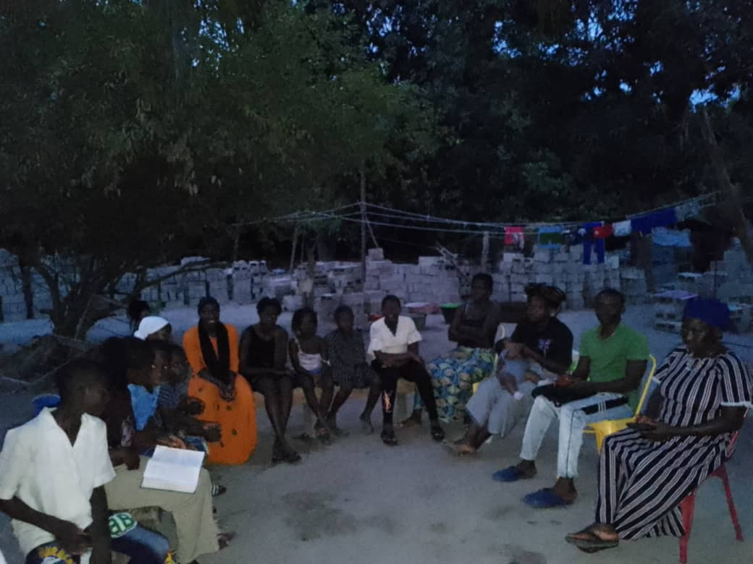

Visit local communities in the evenings to teach local farmers about how to use their land for farming and later plant trees on their land after farming to allow the trees to replace the forest. We also share from the Bible about what the bible says about the environment.

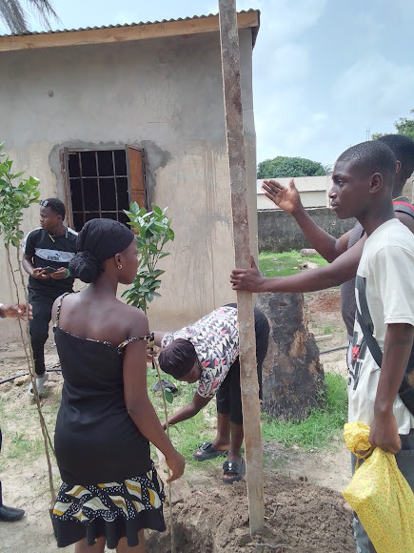

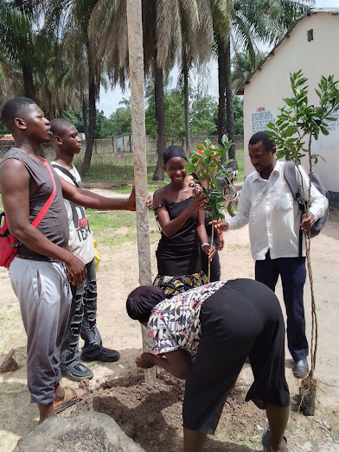 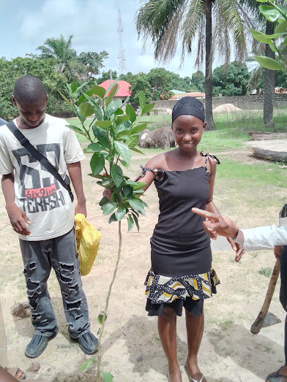 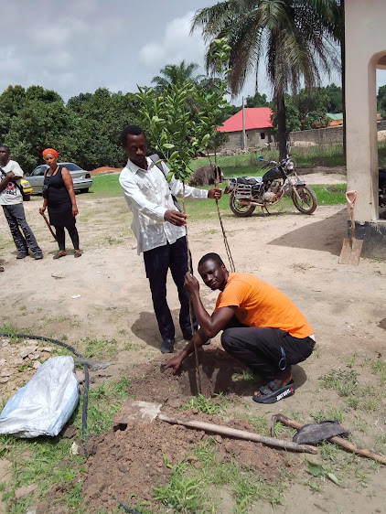 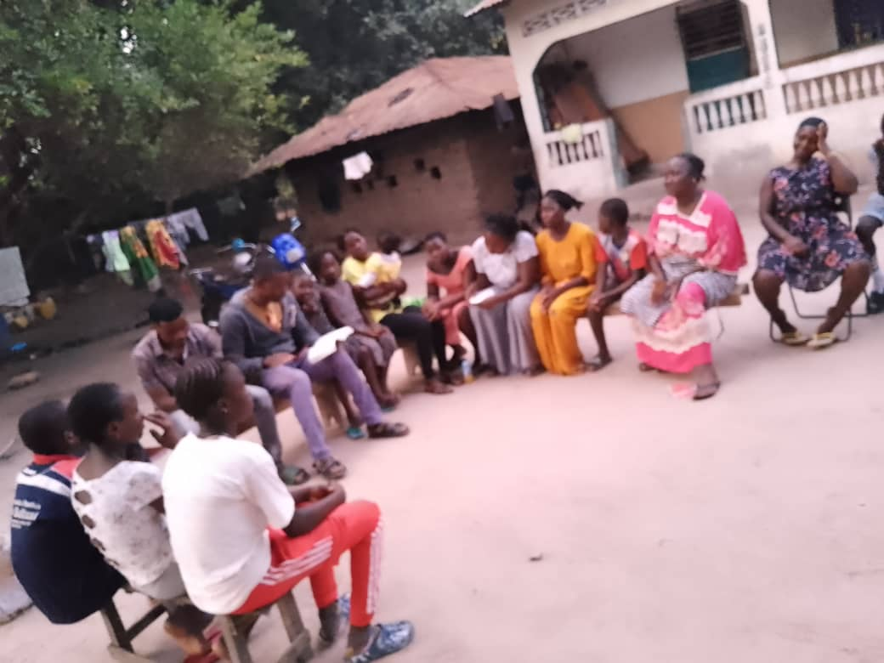

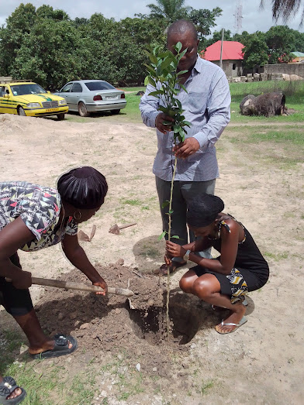

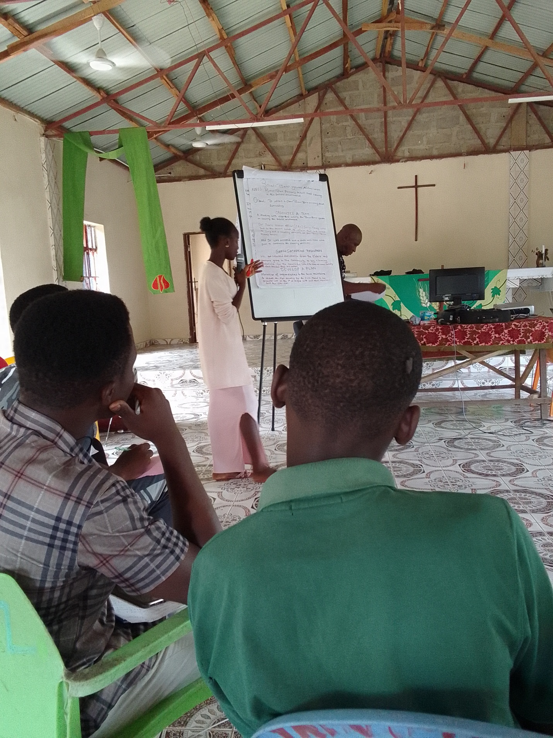

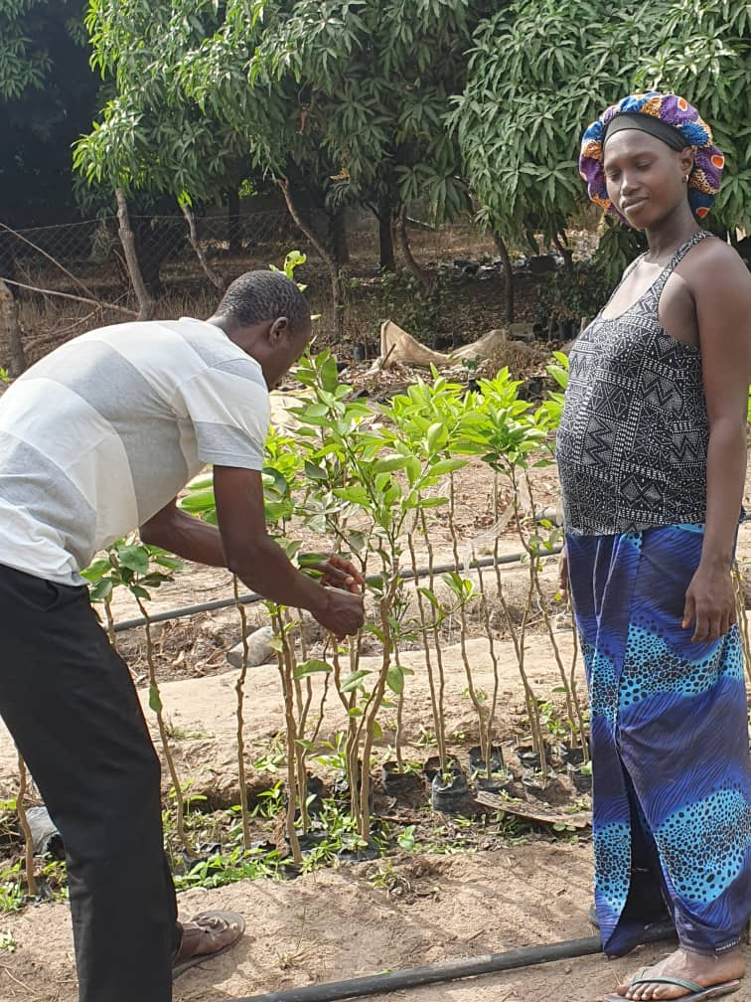

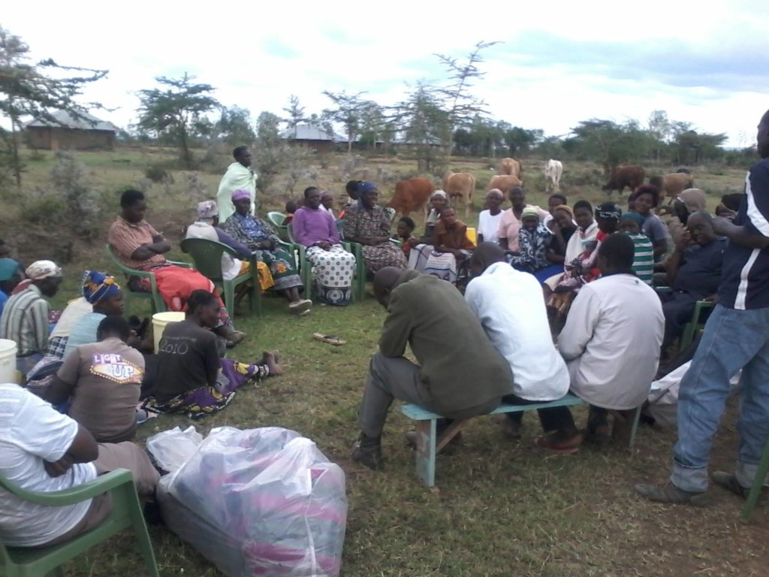

Local Community environmental meetings about how to care for our environment by the youths and pastors in our local communities’ especially animal farmers

By Bishop Samuel Simeon Thomas